Cybersecurity Incident Simulation Report

Objective
Analyze Windows Security logs to identify suspicious activity, Indicators of Compromise (IOCs), and recommend containment actions.

Tools Used
- Windows Event Viewer
- Windows Security Logs

Evidence (Screenshots)
Figure 1: Event ID 4625 - Failed Logon
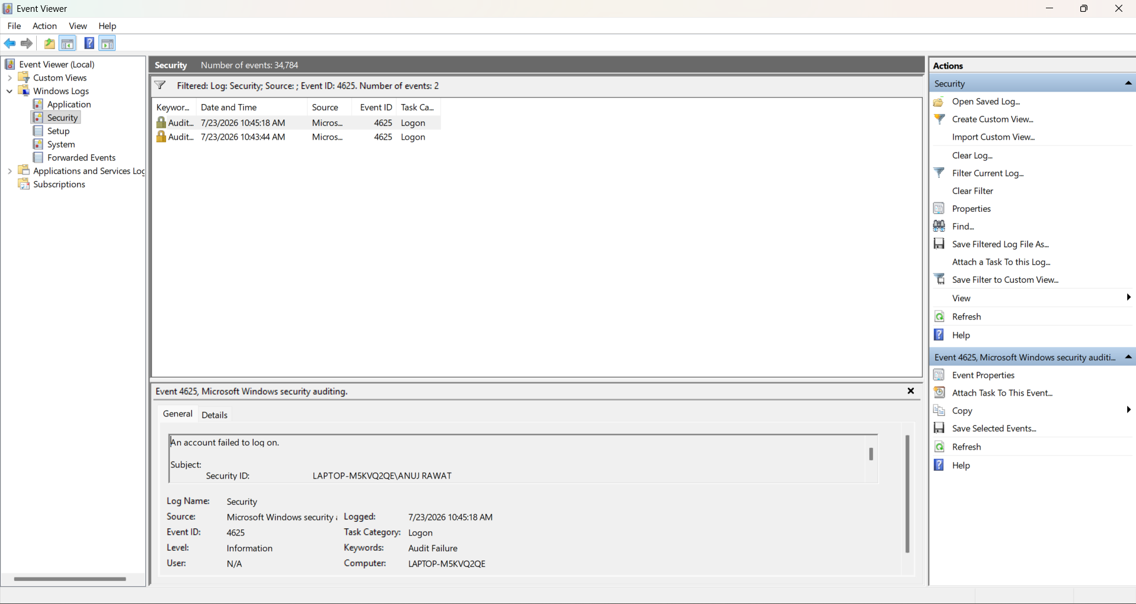
Figure 2: Event ID 4624 - Successful Logon
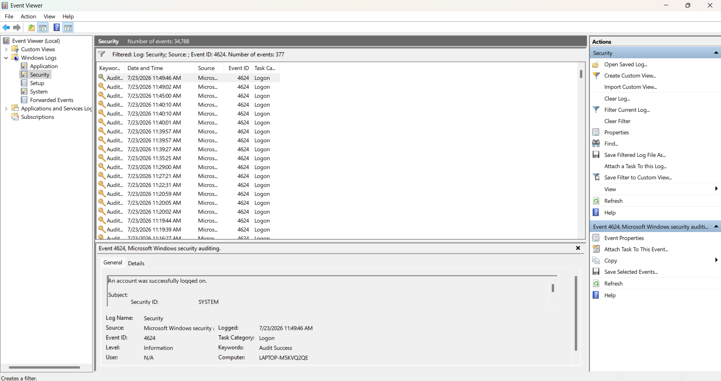
Figure 3: Event ID 4688 - Process Creation
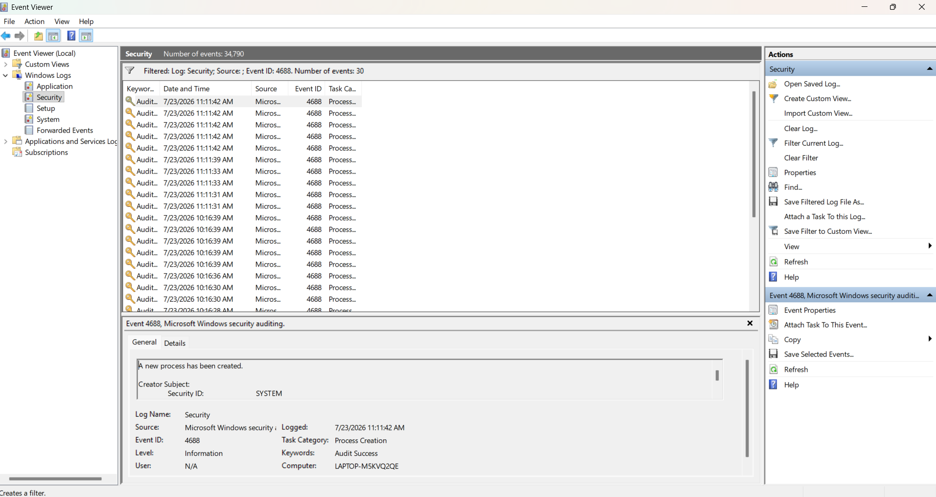
Figure 4: Event ID 4672 - Special Privileges Assigned
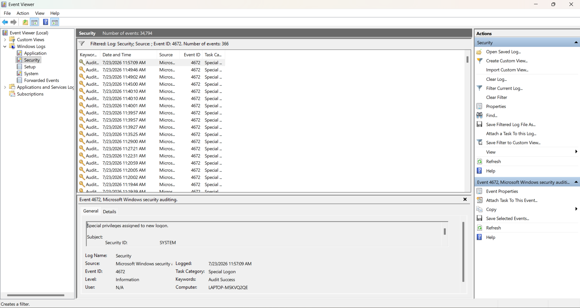

Analysis
Event ID 4625 indicates failed authentication attempts, which may indicate incorrect credentials or brute-force attempts.
Event ID 4624 records successful logins and helps correlate authentication activity.
Event ID 4688 records new process creation, useful for identifying suspicious executable launches.
Event ID 4672 indicates that a logon session received special administrative privileges and should be reviewed.

Detected Anomalies
- Repeated failed login attempts.
- Frequent successful login events.
- Multiple process creation events.
- Administrative privilege assignments.

Indicators of Compromise (IOCs)
- Failed authentication attempts (Event ID 4625).
- Privileged logon events (Event ID 4672).
- Process creation events (Event ID 4688).
- Review timestamps for unusual activity.

Containment and Response
- Investigate failed login attempts.
- Verify user accounts and reset passwords if necessary.
- Review newly created processes.
- Monitor privileged account usage.
- Continue monitoring Security logs.

Conclusion
The Windows Security logs were analyzed successfully. The selected events demonstrate authentication activity, process execution, and privileged logons. No confirmed compromise was observed from the provided logs, but continued monitoring is recommended.

